Question 181 ( Single Topic )

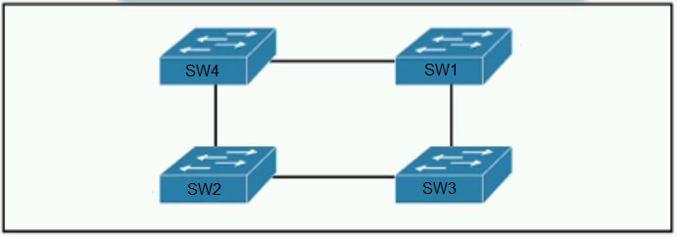  
Refer to the exhibit. Which switch in this configuration will be elected as the root bridge?  
  
SW1: 0C:E0:38:41:86:07 -  
  
SW2: 0C:0E:15:22:05:97 -  
  
SW3: 0C:0E:15:1A:3C:9D -  
  
SW4: 0C:E0:18:A1:B3:19 -

* **A.**SW1
* **B.**SW2
* **C.**SW3
* **D.**SW4

Answer : **C**

Question 183 ( Single Topic )

An engineer needs to configure LLDP to send the port description type length value (TLV). Which command sequence must be implemented?

* **A.**switch(config-if)#lldp port-description
* **B.**switch#lldp port-description
* **C.**switch(config-line)#lldp port-description
* **D.**switch(config)#lldp port-description

Answer : **D**

Question 184 ( Single Topic )

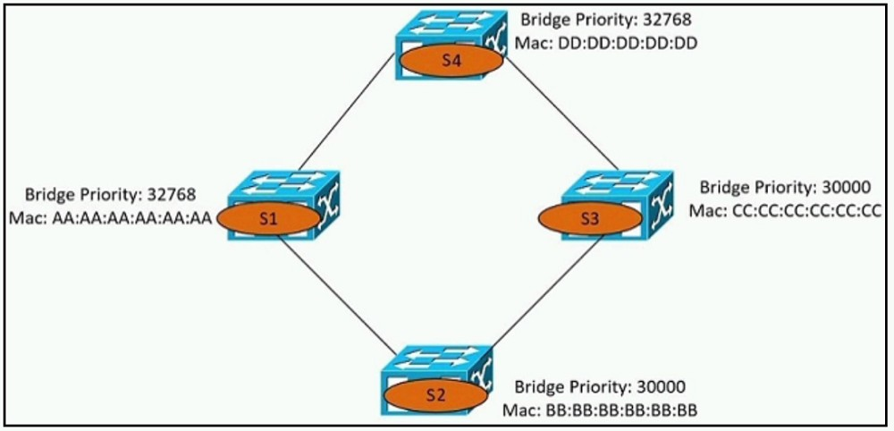  
Refer to the exhibit. Which switch becomes the root bridge?

* **A.**S1
* **B.**S2
* **C.**S3
* **D.**S4

Answer : **B**

Question 185 ( Single Topic )

Which configuration ensures that the switch is always the root for VLAN 750?

* **A.**Switch(config)#spanning-tree vlan 750 priority 38418607
* **B.**Switch(config)#spanning-tree vlan 750 priority 0
* **C.**Switch(config)#spanning-tree vlan 750 root primary
* **D.**Switch(config)#spanning-tree vlan 750 priority 614440

Answer : **C**

Question 186 ( Single Topic )

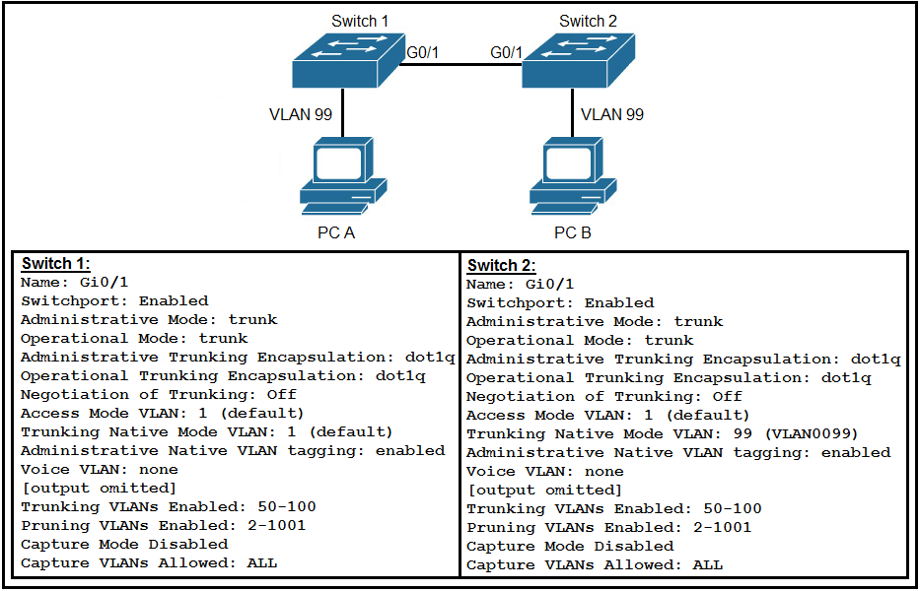  
Refer to the exhibit. After the switch configuration, the ping test fails between PC A and PC B. Based on the output for switch 1, which error must be corrected?

* **A.**The PCs are in the incorrect VLAN.
* **B.**All VLANs are not enabled on the trunk.
* **C.**Access mode is configured on the switch ports.
* **D.**There is a native VLAN mismatch.

Answer : **D**

##### Question 187 ( Single Topic )

DRAG DROP -  
Drag and drop the WLAN components from the left onto the correct descriptions on the right.  
Select and Place:

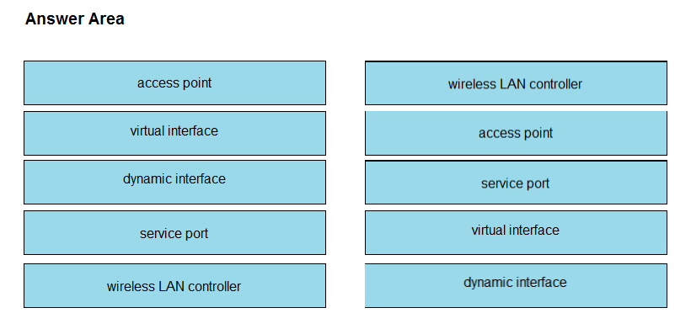

Question 188 ( Single Topic )

Which unified access point mode continues to serve wireless clients after losing connectivity to the Cisco Wireless LAN Controller?

* **A.**local
* **B.**mesh
* **C.**flexconnect
* **D.**sniffer

Answer : **C**

##### V\Question 189 ( Single Topic )

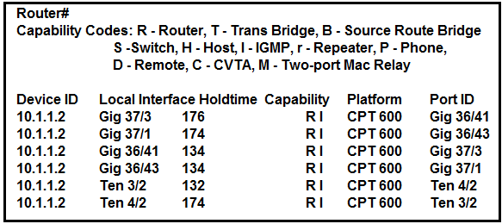  
Refer to the exhibit. Which command provides this output?

* **A.**show ip route
* **B.**show cdp neighbor
* **C.**show ip interface
* **D.**show interface

Answer : **B**

Question 190 ( Single Topic )

Which mode must be used to configure EtherChannel between two switches without using a negotiation protocol?

* **A.**active
* **B.**on
* **C.**auto
* **D.**desirable

Answer : **B**

Question 191 ( Single Topic )

Which mode allows access points to be managed by Cisco Wireless LAN Controllers?

* **A.**bridge
* **B.**lightweight
* **C.**mobility express
* **D.**autonomous

Answer : **B**

Question 192 ( Single Topic )

Which two values or settings must be entered when configuring a new WLAN in the Cisco Wireless LAN Controller GUI? (Choose two.)

* **A.**QoS settings
* **B.**IP address of one or more access points
* **C.**SSID
* **D.**profile name
* **E.**management interface settings

Answer : **CD**

Question 193 ( Single Topic )

Which command is used to specify the delay time in seconds for LLDP to initialize on any interface?

* **A.**lldp timer
* **B.**lldp tlv-select
* **C.**lldp reinit
* **D.**lldp holdtime

Answer : **C**

Question 194 ( Single Topic )

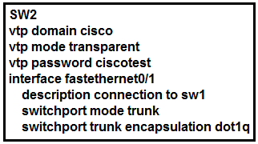  
Refer to the exhibit. How does SW2 interact with other switches in this VTP domain?

* **A.**It transmits and processes VTP updates from any VTP clients on the network on its trunk ports.
* **B.**It processes VTP updates from any VTP clients on the network on its access ports.
* **C.**It receives updates from all VTP servers and forwards all locally configured VLANs out all trunk ports.
* **D.**It forwards only the VTP advertisements that it receives on its trunk ports.

Answer : **D**

Question 195 ( Single Topic )

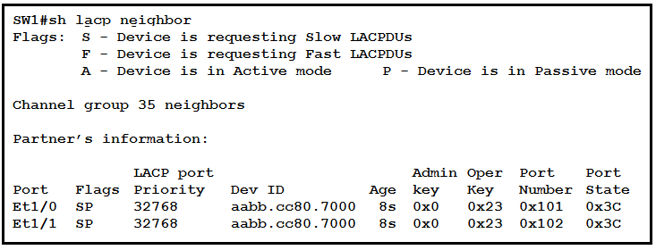  
Refer to the exhibit. Based on the LACP neighbor status, in which mode is the SW1 port channel configured?

* **A.**mode on
* **B.**active
* **C.**passive
* **D.**auto

Answer : **B**

Question 196 ( Single Topic )

Two switches are connected and using Cisco Dynamic Trunking Protocol. SW1 is set to Dynamic Auto and SW2 is set to Dynamic Desirable. What is the result of this configuration?

* **A.**The link becomes an access port.
* **B.**The link is in an error disabled state.
* **C.**The link is in a down state.
* **D.**The link becomes a trunk port.

Answer : **D**

Question 197 ( Single Topic )

A Cisco IP phone receives untagged data traffic from an attached PC. Which action is taken by the phone?

* **A.**It drops the traffic.
* **B.**It allows the traffic to pass through unchanged.
* **C.**It tags the traffic with the native VLAN.
* **D.**It tags the traffic with the default VLAN.

Answer : **B**

Question 198 ( Single Topic )

Which design element is a best practice when deploying an 802.11b wireless infrastructure?

* **A.**allocating nonoverlapping channels to access points that are in close physical proximity to one another
* **B.**disabling TCP so that access points can negotiate signal levels with their attached wireless devices
* **C.**configuring access points to provide clients with a maximum of 5 Mbps
* **D.**setting the maximum data rate to 54 Mbps on the Cisco Wireless LAN Controller

Answer : **A**

Question 199 ( Single Topic )

Refer to the exhibit. The network administrator wants VLAN 67 traffic to be untagged between Switch 1 and Switch 2, while all other VLANs are to remain tagged.  
Which command accomplishes this task?  
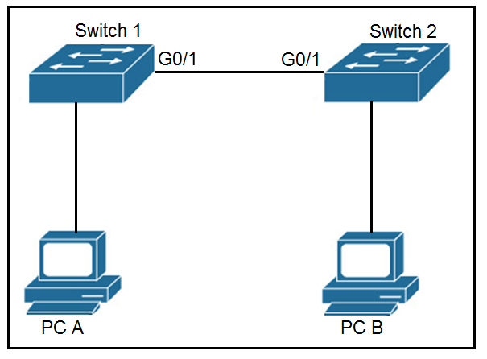

* **A.**switchport access vlan 67
* **B.**switchport trunk allowed vlan 67
* **C.**switchport private-vlan association host 67
* **D.**switchport trunk native vlan 67

Answer : **D**

Question 200 ( Single Topic )

Which two command sequences must be configured on a switch to establish a Layer 3 EtherChannel with an open-standard protocol? (Choose two.)

* **A.**interface GigabitEthernet0/0/1 channel-group 10 mode auto
* **B.**interface GigabitEthernet0/0/1 channel-group 10 mode on
* **C.**interface port-channel 10 no switchport ip address 172.16.0.1 255.255.255.0
* **D.**interface GigabitEthernet0/0/1 channel-group 10 mode active
* **E.**interface port-channel 10 switchport switchport mode trunk

Answer : **CD**

Question 201 ( Single Topic )

Refer to the exhibit. Which two commands when used together create port channel 10? (Choose two.)  
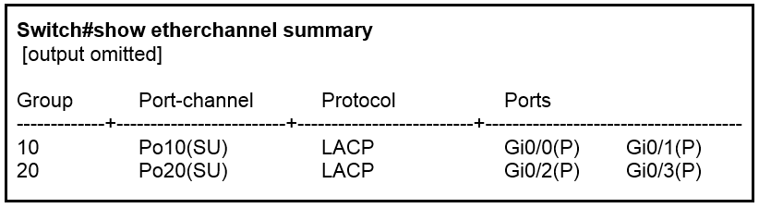

* **A.**int range g0/0-1 channel-group 10 mode active
* **B.**int range g0/0-1 channel-group 10 mode desirable
* **C.**int range g0/0-1 channel-group 10 mode passive
* **D.**int range g0/0-1 channel-group 10 mode auto
* **E.**int range g0/0-1 channel-group 10 mode on

Answer : **AC**

Question 202 ( Single Topic )

Refer to the exhibit. An administrator is tasked with configuring a voice VLAN. What is the expected outcome when a Cisco phone is connected to the  
GigabitEthernet 3/1/4 port on a switch?  
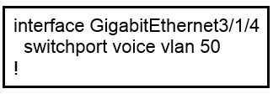

* **A.**The phone and a workstation that is connected to the phone do not have VLAN connectivity.
* **B.**The phone sends and receives data in VLAN 50, but a workstation connected to the phone sends and receives data in VLAN 1.
* **C.**The phone sends and receives data in VLAN 50, but a workstation connected to the phone has no VLAN connectivity.
* **D.**The phone and a workstation that is connected to the phone send and receive data in VLAN 50.

Answer : **B**

Question 203 ( Single Topic )

Refer to the exhibit. Which action is expected from SW1 when the untagged frame is received on the GigabitEthernet0/1 interface?  
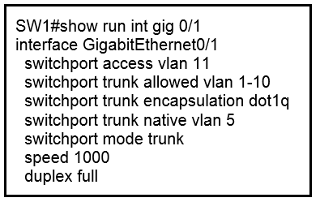

* **A.**The frame is processed in VLAN 1
* **B.**The frame is processed in VLAN 11
* **C.**The frame is processed in VLAN 5
* **D.**The frame is dropped

Answer : **C**

Question 204 ( Single Topic )

Which command is used to enable LLDP globally on a Cisco IOS ISR?

* **A.**lldp run
* **B.**lldp enable
* **C.**lldp transmit
* **D.**cdp run
* **E.**cdp enable

Answer : **A**

Question 205 ( Single Topic )

Which command should you enter to configure an LLDP delay time of 5 seconds?

* **A.**lldp timer 5000
* **B.**lldp holdtime 5
* **C.**lldp reinit 5000
* **D.**lldp reinit 5  
  Answer : **D**

Question 206 ( Single Topic )

In a CDP environment, what happens when the CDP interface on an adjacent device is configured without an IP address?

* **A.**CDP becomes inoperable on that neighbor
* **B.**CDP uses the IP address of another interface for that neighbor
* **C.**CDP operates normally, but it cannot provide IP address information for that neighbor
* **D.**CDP operates normally, but it cannot provide any information for that neighbor

Answer : **C**

##### Question 207 ( Single Topic )

DRAG DROP -  
Drag and drop the benefits of a Cisco Wireless Lan Controller from the left onto the correct examples on the right.  
Select and Place:

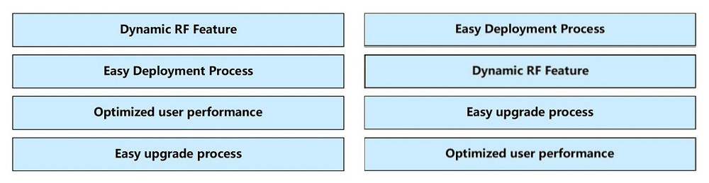

Question 208 ( Single Topic )

When configuring an EtherChannel bundle, which mode enables LACP only if a LACP device is detected?

* **A.**Passive
* **B.**Desirable
* **C.**On
* **D.**Auto
* **E.**Active

Answer : **A**

Question 209 ( Single Topic )

Refer to the exhibit. Which VLAN ID is associated with the default VLAN in the given environment?  
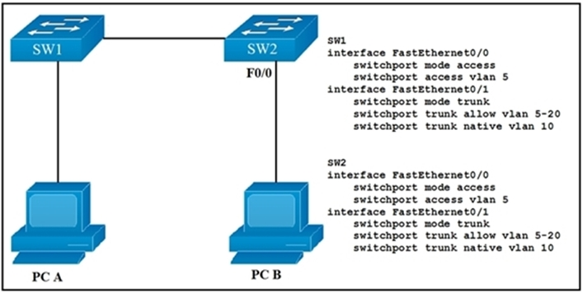

* **A.**VLAN 1
* **B.**VLAN 5
* **C.**VLAN 10
* **D.**VLAN 20

Answer : **A**

Question 210 ( Single Topic )

Which two VLAN IDs indicate a default VLAN? (Choose two.)

* **A.**0
* **B.**1
* **C.**1005
* **D.**1006
* **E.**4096

Answer : **BC**

Question 211 ( Single Topic )

Which two pieces of information about a Cisco device can Cisco Discovery Protocol communicate? (Choose two.)

* **A.**the native VLAN
* **B.**the trunking protocol
* **C.**the VTP domain
* **D.**the spanning-tree priority
* **E.**the spanning-tree protocol

Answer : **AC**

Question 212 ( Single Topic )

After you deploy a new WLAN controller on your network, which two additional tasks should you consider? (Choose two.)

* **A.**deploy load balancers
* **B.**configure additional vlans
* **C.**configure multiple VRRP groups
* **D.**deploy POE switches
* **E.**configure additional security policies

Answer : **AE**

Question 213 ( Single Topic )

Refer to the exhibit. How will switch SW2 handle traffic from VLAN 10 on SW1?  
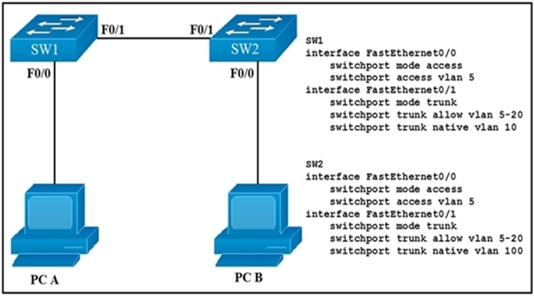

* **A.**It sends the traffic to VLAN 10.
* **B.**It sends the traffic to VLAN 100.
* **C.**It drops the traffic.
* **D.**It sends the traffic to VLAN 1.

Answer : **B**

Question 214 ( Single Topic )

Which two commands can you use to configure an actively negotiate EtherChannel? (Choose two.)

* **A.**channel-group 10 mode on
* **B.**channel-group 10 mode auto
* **C.**channel-group 10 mode passive
* **D.**channel-group 10 mode desirable
* **E.**channel-group 10 mode active

Answer : **DE**

Question 215 ( Single Topic )

How does STP prevent forwarding loops at OSI Layer 2?

* **A.**TTL
* **B.**MAC address forwarding
* **C.**Collision avoidance
* **D.**Port blocking

Answer : **D**

Question 216 ( Single Topic )

Which two statements about VTP are true? (Choose two.)

* **A.**All switches must be configured with the same VTP domain name
* **B.**All switches must be configured to perform trunk negotiation
* **C.**All switches must be configured with a unique VTP domain name
* **D.**The VTP server must have the highest revision number in the domain
* **E.**All switches must use the same VTP version

Answer : **AE**

Question 217 ( Single Topic )

Which type does a port become when it receives the best BPDU on a bridge?

* **A.**The designated port
* **B.**The backup port
* **C.**The alternate port
* **D.**The root port

Answer : **D**

Question 218 ( Single Topic )

Which value can you modify to configure a specific interface as the preferred forwarding interface?

* **A.**The interface number
* **B.**The port priority
* **C.**The VLAN priority
* **D.**The hello time

Answer : **B**

Question 219 ( Single Topic )

Which statement about Cisco Discovery Protocol is true?

* **A.**It is a Cisco-proprietary protocol.
* **B.**It runs on the network layer.
* **C.**It can discover information from routers, firewalls, and switches.
* **D.**It runs on the physical layer and the data link layer.

Answer : **A**

Question 220 ( Single Topic )

What are two reasons a network administrator would use CDP? (Choose two.)

* **A.**to verify the type of cable interconnecting two devices
* **B.**to determine the status of network services on a remote device
* **C.**to obtain VLAN information from directly connected switches
* **D.**to verify Layer 2 connectivity between two devices when Layer 3 fails
* **E.**to obtain the IP address of a connected device in order to telnet to the device
* **F.**to determine the status of the routing protocols between directly connected routers

Answer : **DE**

Question 221 ( Single Topic )

What are two benefits of using VTP in a switching environment? (Choose two.)

* **A.**It allows switches to read frame tags.
* **B.**It allows ports to be assigned to VLANs automatically.
* **C.**It maintains VLAN consistency across a switched network.
* **D.**It allows frames from multiple VLANs to use a single interface.
* **E.**It allows VLAN information to be automatically propagated throughout the switching environment.

Answer : **CE**

Question 222 ( Single Topic )

Which three statements are typical characteristics of VLAN arrangements? (Choose three.)

* **A.**A new switch has no VLANs configured.
* **B.**Connectivity between VLANs requires a Layer 3 device.
* **C.**VLANs typically decrease the number of collision domains.
* **D.**Each VLAN uses a separate address space.
* **E.**A switch maintains a separate bridging table for each VLAN.
* **F.**VLANs cannot span multiple switches.

Answer : **BDE**

Question 223 ( Single Topic )

On a corporate network, hosts on the same VLAN can communicate with each other, but they are unable to communicate with hosts on different VLANs. What is needed to allow communication between the VLANs?

* **A.**a router with subinterfaces configured on the physical interface that is connected to the switch
* **B.**a router with an IP address on the physical interface connected to the switch
* **C.**a switch with an access link that is configured between the switches
* **D.**a switch with a trunk link that is configured between the switches

Answer : **A**

Question 224 ( Single Topic )

Which statement about LLDP is true?

* **A.**It is a Cisco proprietary protocol.
* **B.**It is configured in global configuration mode.
* **C.**The LLDP update frequency is a fixed value.
* **D.**It runs over the transport layer.

Answer : **B**

Question 225 ( Single Topic )

What is a function of Wireless LAN Controller?

* **A.**register with a single access point that controls traffic between wired and wireless endpoints
* **B.**use SSIDs to distinguish between wireless clients
* **C.**send LWAPP packets to access points
* **D.**monitor activity on wireless and wired LANs

Answer : **C**

Question 226 ( Single Topic )

Which technology is used to improve web traffic performance by proxy caching?

* **A.**WSA
* **B.**Firepower
* **C.**ASA
* **D.**FireSIGHT

Answer : **A**

Question 227 ( Single Topic )

What criteria is used first during the root port selection process?

* **A.**local port ID
* **B.**lowest path cost to the toot bridge
* **C.**lowest neighbor's bridge ID
* **D.**lowest neighbor's port ID

Answer : **B**

Question 228 ( Single Topic )

Which statement about VLAN configuration is true?

* **A.**The switch must be in VTP server or transparent mode before you can configure a VLAN
* **B.**The switch must be in config-vlan mode before you configure an extended VLAN
* **C.**Dynamic inter-VLAN routing is supported on VLAN2 through VLAN 4064
* **D.**A switch in VTP transparent mode save the VLAN databases to the running configuration only

Answer : **A**

Question 229 ( Single Topic )

Refer to the exhibit. What two conclusions should be made about this configuration? (Choose two.)  
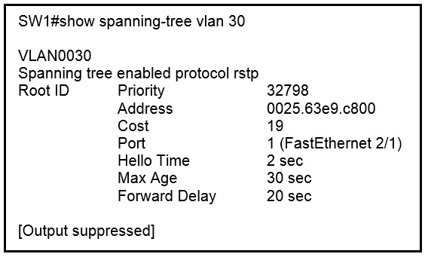

* **A.**The root port is FastEthernet 2/1
* **B.**The designated port is FastEthernet 2/1
* **C.**The spanning-tree mode is PVST+
* **D.**This is a root bridge
* **E.**The spanning-tree mode is Rapid PVST+

Answer : **AE**

Question 230 ( Single Topic )

A network engineer must create a diagram of a multivendor network. Which command must be configured on the Cisco devices so that the topology of the network is allowed to be mapped?

* **A.**Device(config)#lldp run
* **B.**Device(config)#cdp run
* **C.**Device(config-if)#cdp enable
* **D.**Device(config)#flow-sampler-map topology

Answer : **A**

Question 231 ( Single Topic )

How do AAA operations compare regarding user identification, user services, and access control?

* **A.**Authorization provides access control, and authentication tracks user services
* **B.**Authentication identifies users, and accounting tracks user services
* **C.**Accounting tracks user services, and authentication provides access control
* **D.**Authorization identifies users, and authentication provides access control

Answer : **B**

Question 232 ( Single Topic )

What is the difference between RADIUS and TACACS+?

* **A.**RADIUS logs all commands that are entered by the administrator, but TACACS+ logs only start, stop, and interim commands.
* **B.**TACACS+ separates authentication and authorization, and RADIUS merges them.
* **C.**TACACS+ encrypts only password information, and RADIUS encrypts the entire payload.
* **D.**RADIUS is most appropriate for dial authentication, but TACACS+ can be used for multiple types of authentication.

Answer : **B**

Question 233 ( Single Topic )

What is a difference between local AP mode and FlexConnect AP mode?

* **A.**Local AP mode creates two CAPWAP tunnels per AP to the WLC
* **B.**Local AP mode causes the AP to behave as if it were an autonomous AP
* **C.**FlexConnect AP mode fails to function if the AP loses connectivity with the WLC
* **D.**FlexConnect AP mode bridges the traffic from the AP to the WLC when local switching is configured

Answer : **A**

Question 234 ( Single Topic )

The SW1 interface g0/1 is in the down/down state. What are two reasons for the interface condition? (Choose two.)

* **A.**There is a protocol mismatch
* **B.**There is a duplex mismatch
* **C.**The interface is shut down
* **D.**The interface is error-disabled
* **E.**There is a speed mismatch

Answer : **DE**

Question 235 ( Single Topic )

How will Link Aggregation be implemented on a Cisco Wireless LAN Controller?

* **A.**The EtherChannel must be configured in ג€mode activeג€.
* **B.**When enabled, the WLC bandwidth drops to 500 Mbps.
* **C.**To pass client traffic, two or more ports must be configured.
* **D.**One functional physical port is needed to pass client traffic.

Answer : **D**

Question 236 ( Single Topic )

Which two conditions must be met before SSH operates normally on a Cisco IOS switch? (Choose two.)

* **A.**IP routing must be enabled on the switch.
* **B.**A console password must be configured on the switch.
* **C.**Telnet must be disabled on the switch.
* **D.**The switch must be running a k9 (crypto) IOS image.
* **E.**The ip domain-name command must be configured on the switch.

Answer : **DE**

Question 237 ( Single Topic )

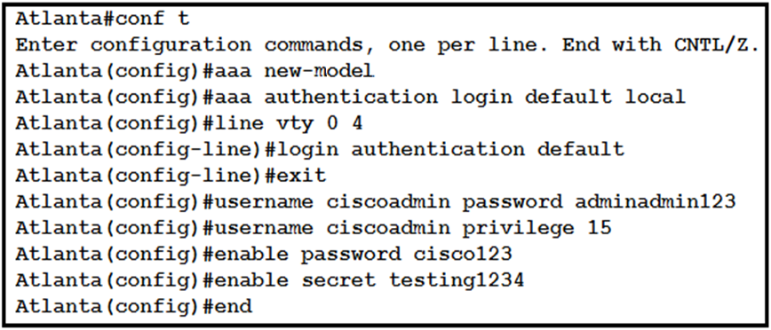  
Refer to the exhibit. Which password must an engineer use to enter the enable mode?

* **A.**adminadmin123
* **B.**cisco123
* **C.**default
* **D.**testing1234

Answer : **D**

Question 238 ( Single Topic )

Which state does the switch port move to when PortFast is enabled?

* **A.**blocking
* **B.**listening
* **C.**learning
* **D.**forwarding

Answer : **D**

Question 239 ( Single Topic )

Which protocol prompts the Wireless LAN Controller to generate its own local web administration SSL certificate for GUI access?

* **A.**RADIUS
* **B.**HTTPS
* **C.**TACACS+
* **D.**HTTP

Answer : **B**

Question 240 ( Single Topic )

An engineer must configure interswitch VLAN communication between a Cisco switch and a third-party switch. Which action should be taken?

* **A.**configure DSCP
* **B.**configure IEEE 802.1q
* **C.**configure ISL
* **D.**configure IEEE 802.1p

Answer : **B**

Question 241 ( Single Topic )

An engineer requires a switch interface to actively attempt to establish a trunk link with a neighbor switch. What command must be configured?

* **A.**switchport mode trunk
* **B.**switchport mode dynamic desirable
* **C.**switchport nonegotiate
* **D.**switchport mode dynamic auto

Answer : **B**

Question 242 ( Single Topic )

Refer to the exhibit. After the election process, what is the root bridge in the HQ LAN?  
  
Switch 1: 0C:E0:38:81:32:58 -  
  
Switch 2: 0C:0E:15:22:1A:61 -  
  
Switch 3: 0C:0E:15:1D:3C:9A -  
  
Switch 4: 0C:E0:19:A1:4D:16 -  
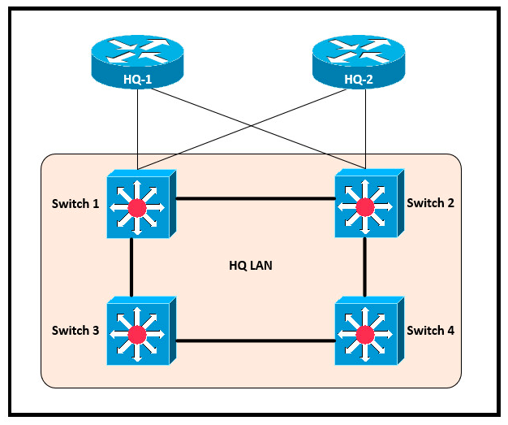

* **A.**Switch 1
* **B.**Switch 2
* **C.**Switch 3
* **D.**Switch 4

Answer : **C**

Question 243 ( Single Topic )

An engineer must establish a trunk link between two switches. The neighboring switch is set to trunk or desirable mode. What action should be taken?

* **A.**configure switchport nonegotiate
* **B.**configure switchport mode dynamic desirable
* **C.**configure switchport mode dynamic auto
* **D.**configure switchport trunk dynamic desirable

Answer : **C**

Question 244 ( Single Topic )

Which spanning-tree enhancement avoids the learning and listening states and immediately places ports in the forwarding state?

* **A.**BPDUfilter
* **B.**PortFast
* **C.**Backbonefast
* **D.**BPDUguard

Answer : **B**

Question 245 ( Single Topic )

How does the dynamically-learned MAC address feature function?

* **A.**The CAM table is empty until ingress traffic arrives at each port
* **B.**Switches dynamically learn MAC addresses of each connecting CAM table.
* **C.**The ports are restricted and learn up to a maximum of 10 dynamically-learned addresses
* **D.**It requires a minimum number of secure MAC addresses to be filled dynamically

Answer : **A**

Question 246 ( Single Topic )

When using Rapid PVST+, which command guarantees the switch is always the root bridge for VLAN 200?

* **A.**spanning-tree vlan 200 priority 614440
* **B.**spanning-tree vlan 200 priority 0
* **C.**spanning-tree vlan 200 root primary
* **D.**spanning-tree vlan 200 priority 38813258

Answer : **B**

Question 247 ( Single Topic )

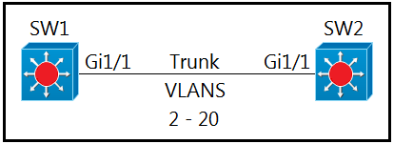  
Refer to the exhibit. Which command must be executed for Gi1/1 on SW1 to passively become a trunk port if Gi1/1 on SW2 is configured in desirable or trunk mode?

* **A.**switchport mode dynamic auto
* **B.**switchport mode dot1-tunnel
* **C.**switchport mode dynamic desirable
* **D.**switchport mode trunk

Answer : **A**

##### Question 249 ( Single Topic )

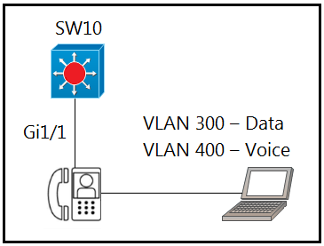  
Refer to the exhibit. An engineer must configure GigabitEthernet1/1 to accommodate voice and data traffic. Which configuration accomplishes this task?

* **A.**interface gigabitethernet1/1 switchport mode access switchport access vlan 300 switchport voice vlan 400
* **B.**interface gigabitethernet1/1 switchport mode trunk switchport trunk vlan 300 switchport trunk vlan 400
* **C.**interface gigabitethernet1/1 switchport mode access switchport voice vlan 300 switchport access vlan 400
* **D.**interface gigabitethernet1/1 switchport mode trunk switchport trunk vlan 300 switchport voice vlan 400

Answer : **A**

Question 250 ( Single Topic )

An engineer needs to add an old switch back into a network. To prevent the switch from corrupting the VLAN database, with action must be taken?

* **A.**Add the switch in the VTP domain with a lower revision number.
* **B.**Add the switch in the VTP domain with a higher revision number.
* **C.**Add the switch with DTP set to dynamic desirable.
* **D.**Add the switch with DTP set to desirable.

Answer : **A**